#### **Autonomous driving (case study)**

## To help you practice strategies for machine learning, in this week we’ll present another scenario and ask how you would act. We think this “simulator” of working in a machine learning project will give a task of what leading a machine learning project could be like!

You are employed by a startup building self-driving cars. You are in charge of detecting road signs (stop sign, pedestrian crossing sign, construction ahead sign) and traffic signals (red and green lights) in images. The goal is to recognize which of these objects appear in each image. As an example, the above image contains a pedestrian crossing sign and red traffic lights

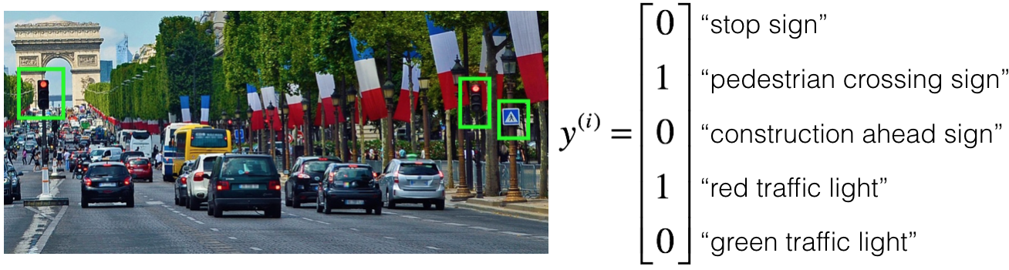

Your 100,000 labeled images are taken using the front-facing camera of your car. This is also the distribution of data you care most about doing well on. You think you might be able to get a much larger dataset off the internet, that could be helpful for training even if the distribution of internet data is not the same.

Your goal is to detect road signs (stop sign, pedestrian crossing sign, construction ahead sign) and traffic signals (red and green lights) in images. The goal is to recognize which of these objects appear in each image. You plan to use a deep neural network with ReLU units in the hidden layers

**ASSIGNMENT COMPLETED. SCORE 100.0%**